COLLABORATION AGREEMENT 2026-2027

The present contract has the goal of formalizing the partnership between JBC soldering S.L. and CTM Campus Tirol Motosport.
The goal of this partnership consists of:
- Support from JBC Soldering S.L. for CTM Campus Tirol Motosport by providing the following products free of charge:
Amount Material Ref.
1 B.IRON 100 Light Battery-Powered Soldering BIL-5B
1 Chip Cartridge 1.9 C245016
1 Barrel Cartridge Ø 0.8 C245790
1 Chisel Cartridge 3.2 x 1.2 C245911
1 Conical Bent Cartridge Ø 0.4 C245029
1 Chisel Cartridge 2.3 x 0.7 C210007
1 Knife Cartridge 2.5 x 0.3 C210033
1 Conical Bent Cartridge Ø 0.7 C210004
- as well as, the coverage of the shipment fee of the materials provided by JBC Soldering S.L. except for taxes which may apply during the importation process.
With the support of these materials, JBC Soldering S.L. becomes a formal sponsor of all the relevant channels managed by CTM Campus Tirol Motosport.
- In return, CTM Campus Tirol Motosport offers the disclosure of JBC Soldering S.L. brand by the following means:

  - JBC Soldering S.L brand will be present in the official website of
CTM Campus Tirol Motosport (https://ct-motorsport.at/), as an official sponsor and linked to our JBC website (www.jbctools.com).

  - The use of JBC Soldering S.L. brand and the sponsored products on their social media platforms to help promote this collaboration.

- As a special request, JBC asks for the following means:

- Feedback regarding sponsored material. This feedback can be provided via a 15-to-30-minute interview and/or a digital survey.

- To be provided with a bank of images of the team members using JBC equipment, as well as their permission for commercial usage.

The present agreement is valid for two year, with the possibility of being renewed in case there is desire of both parties to do so upon mutual agreement.

Both entities declare to be in compliance with the conditions laid out in this document, so that they will sign it as a sign of their conformity.

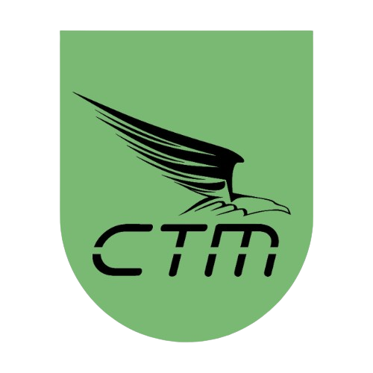
CRT Formula Student
Lukas Eppacher
Head of Powertrain
Date: 23.02.2026


JBC Soldering S.L.
Magda Sanchez
Sales Manager
Date: _____________

Shipment Data:
Contact: Lukas Eppacher
Email: lukas.eppacher@ct-motorsport.at
Phone +436608650017
Address: Technikerstraße 13, 6020 Innsbruck, AUSTRIA
Data to create the order:
Official name of the institution: Campus Tirol Motorsport
Invoice Address: Technikerstraße 13, 6020 Innsbruck, AUSTRIA
VAT ID: ATU72243235
Email: lukas.eppacher@ct-motorsport.at
Phone: +436608650017

